LOG Management:

tail -f /var/log/syslog

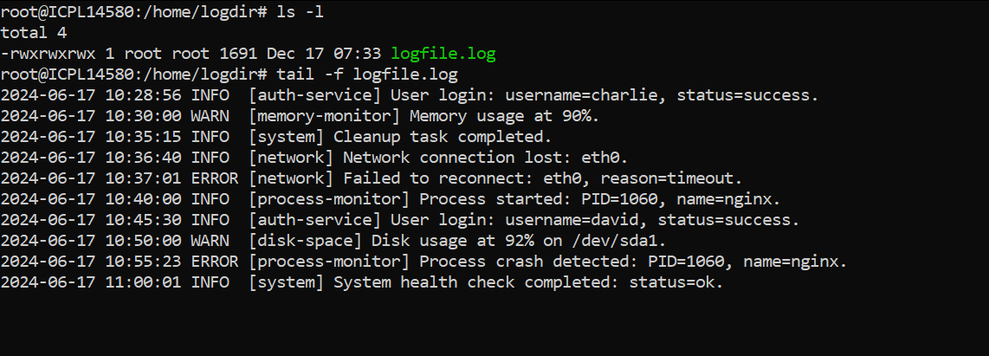

tail -n 50 /var/log/syslog

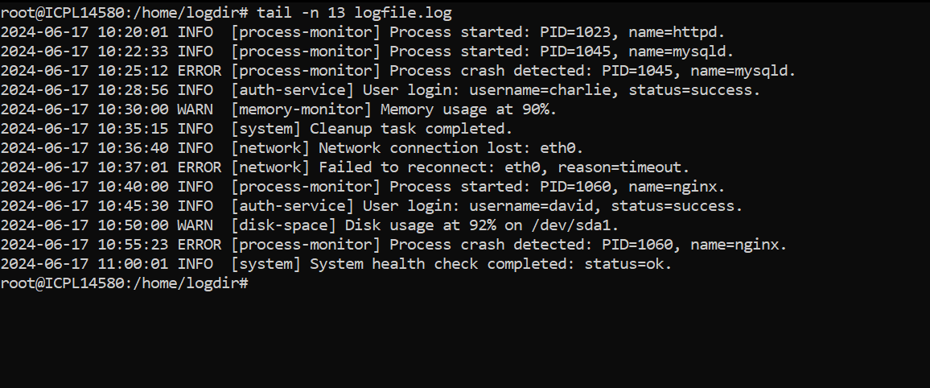

head -n 20 /var/log/syslog

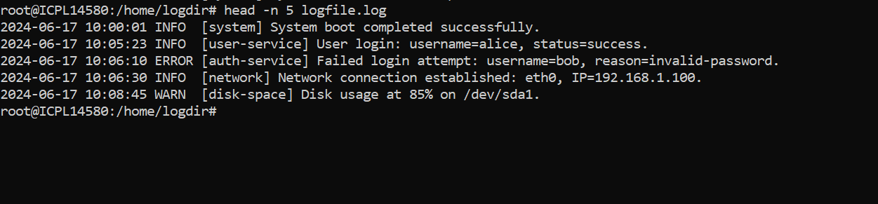

head -n 20 /var/log/syslog | tail -n 10

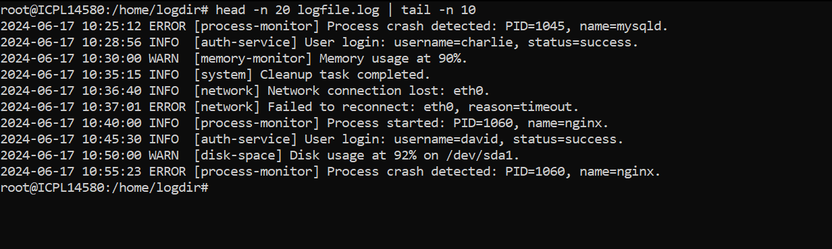

grep "error" /var/log/syslog

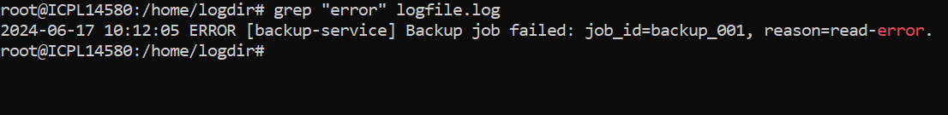

grep -i "error" /var/log/syslog

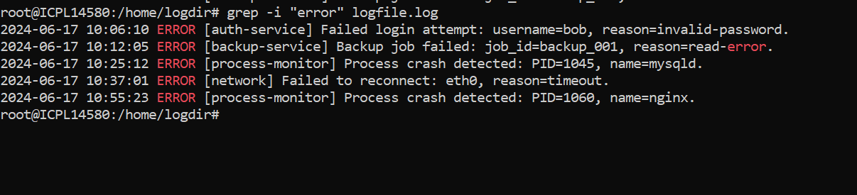

less /var/log/syslog

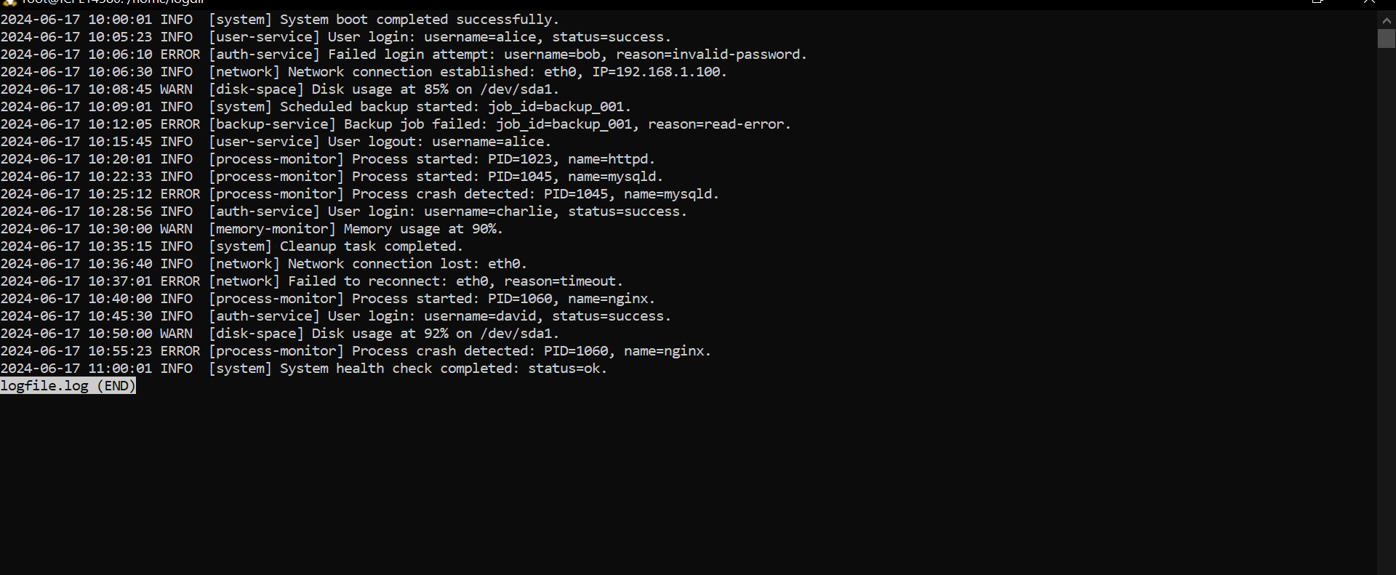

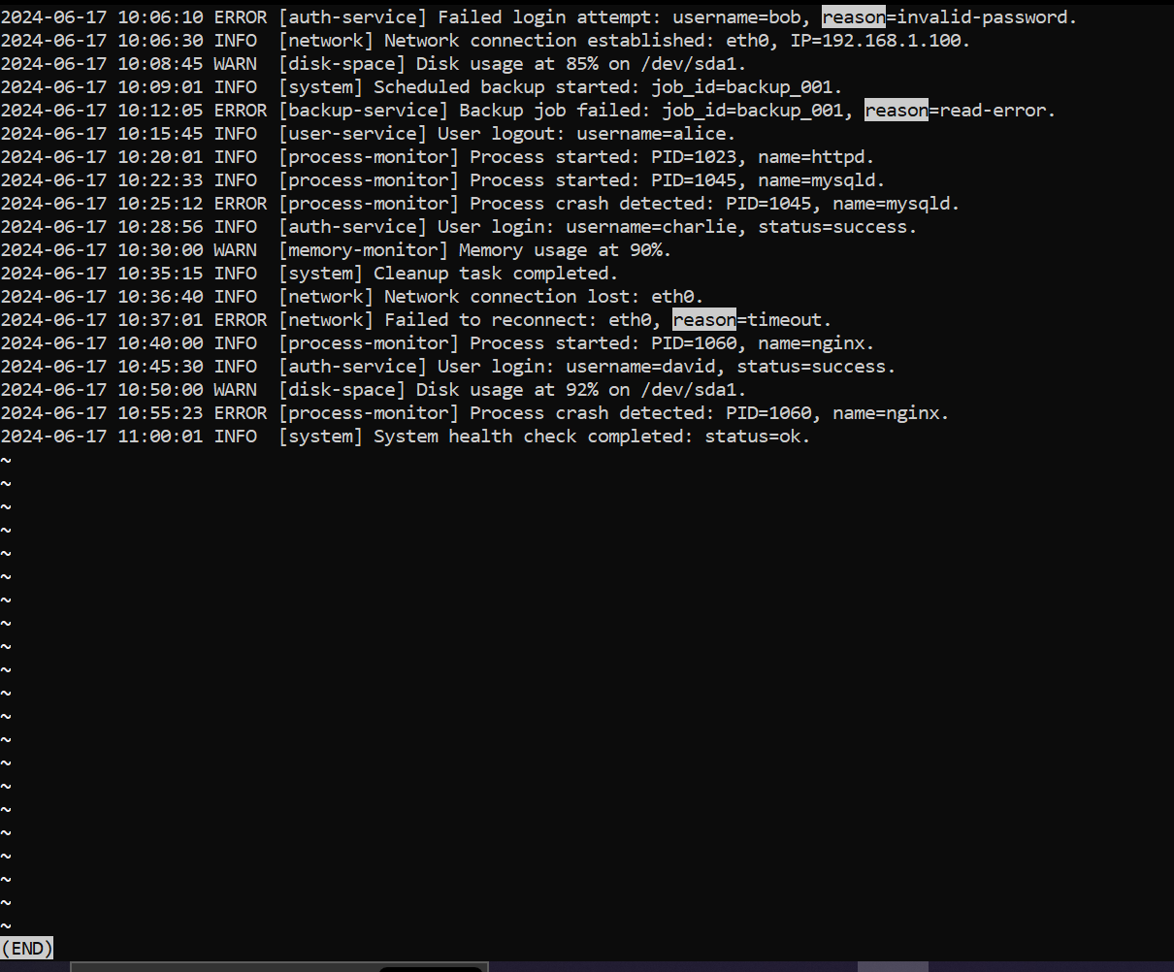

cat /var/log/syslog

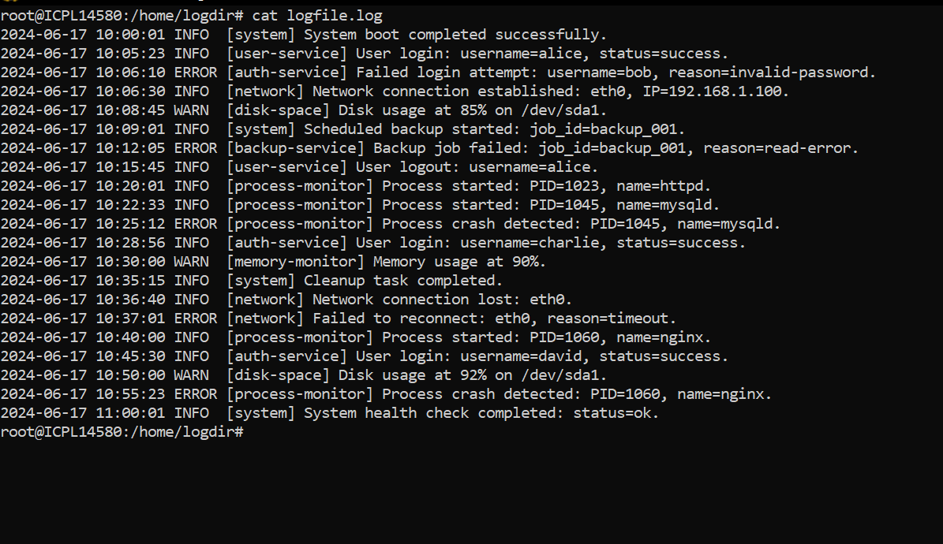

cat log1.txt log2.txt > combined_logs.txt

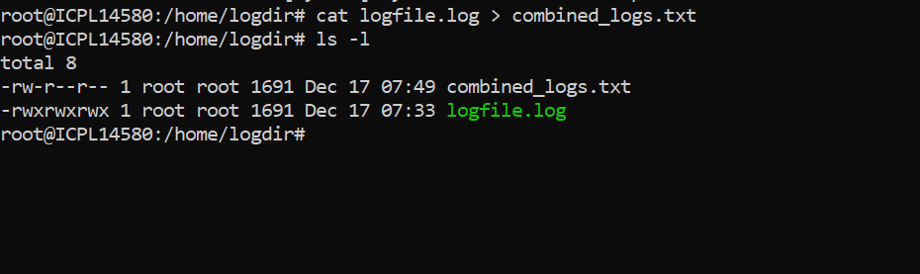

journalctl –b

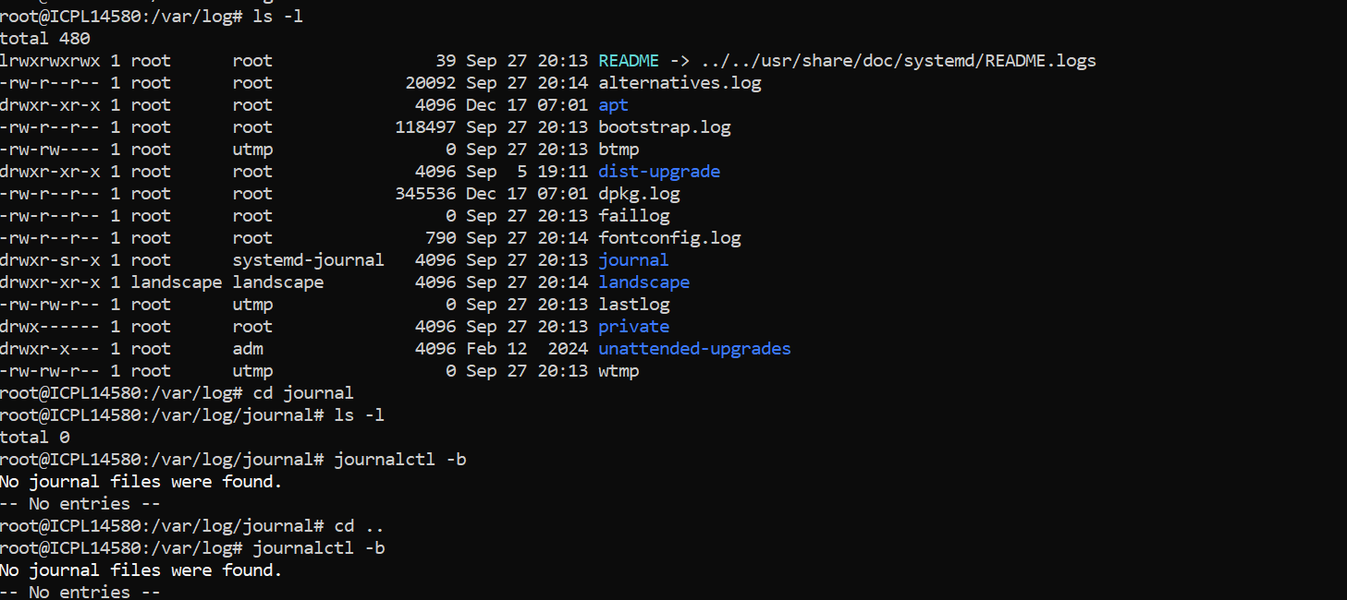

journalctl -u nginx.service



tail -f /var/log/nginx/access.log

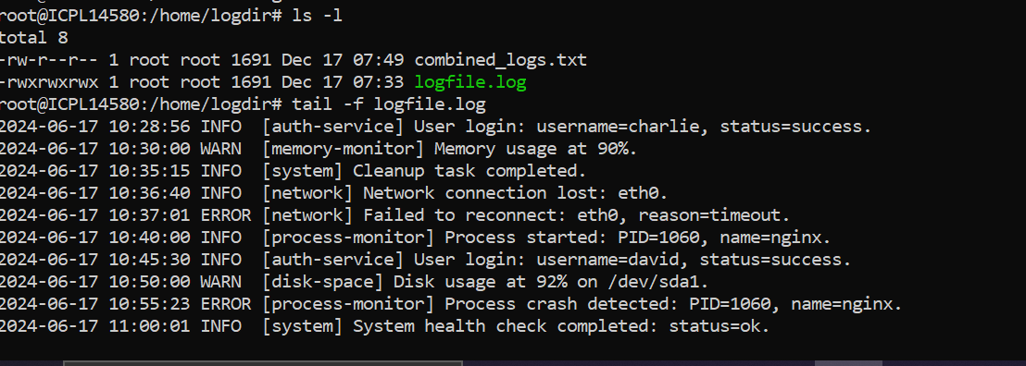

head -n 10 file.log && tail -n 10 file.log

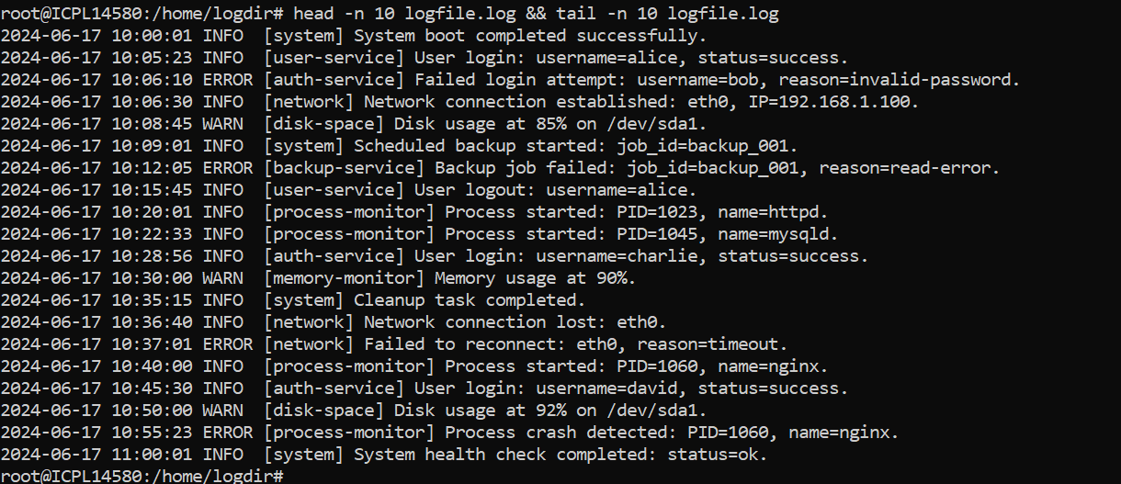

grep -i "failed" /var/log/syslog

